**ECO THRIVE MARKET**

A Project Report

submitted in partial fulfillment of the requirements

of

**Applied Cloud Computing for Software Development**

by

**SAI NARAYANA A 20AK1A3038**

**SURYA TEJA K 20AK1A3045**

**RAVI TEJA K 20AK1A3034**

**DINESH K P 20AK1A3009**

**SWETHA A 20AK1A3048**

Under the Esteemed Guidance of

**UMA MAHESHWARI R**

**ACKNOWLEDGEMENT**

We would like to express our sincere gratitude to all those who have contributed to the successful completion of this project.

Firstly, we extend our heartfelt thanks to **Uma Maheshwari R**, whose expertise and guidance helped us navigate challenges and make informed decisions at every stage of the project.

We would like to express our special thanks to the **TechSaksham team** for their time and efforts. Your useful advice and suggestions were really helpful to us during the project’s completion. In this aspect, I am eternally grateful to you.

Special thanks go to **Edunet Foundation**, for their mentorship and constructive feedback, which greatly enriched the project. Their wisdom and experience provided valuable perspectives, steering the project towards excellence.

We would like to acknowledge the tireless efforts of the team members and who dedicated their time and expertise to various aspects of the project. Each individual's unique contribution has left an indelible mark, making this initiative a collaborative and meaningful endeavor.

Finally, thanking all of them who participated in making the Eco Thrive Market project a great success.

Thank you all for being an integral part of this endeavor.

#### **ABSTRACT**

There is a clear gap in the market as a result of the growing demand for eco-friendly products brought about by the increased awareness of environmental sustainability. This disparity results from the difficulty in establishing connections between consumers who care about the environment and trustworthy vendors of sustainable products. The Eco Thrive Market project seeks to close this gap by launching a specialized platform in response. This platform will function as a marketplace, enabling the smooth exchange of information between environmentally concerned consumers and reliable providers of sustainable goods. Eco Thrive Market wants to create a thriving ecosystem where customers can readily find and support ecologically friendly solutions by utilizing technology to improve accessibility and transparency.

**(i)**

**LIST OF FIGURES**

|  |  |  |
| --- | --- | --- |
| **Figures** | **Description** | **Page No.** |
|  | Login Page | 20 |
|  | Register Page | 20 |
|  | Home Page | 21 |
|  | Shop Page | 21 |
|  | Orders Page | 22 |
|  | About us Page | 22 |
|  | Contact Page | 23 |
|  | Admin Dashboard Page | 23 |
|  | Admin Orders Page | 24 |
|  | Admin Products Page | 24 |

**(ii)**

**TABLE OF CONTENTS**

Abstract …………………………………………………………………………………..(i)

List of Figures ……………………………………………………………………………(ii)

**Chapter 1.**  **Introduction**…………………………………………………………. .  **1**

1.1 Problem Statement……………………………………………………. 1

1.2 Problem Definition……………………………………………………. 1

1.3 Expected Outcomes……………………………………………………. 2

1.4. Organization of the Report…………………………………………. 3

**Chapter 2.**  **Literature Survey** ……………………………………………………. **4**

2.1 Brief Introduction of the paper……………………………………… 4

2.2 Technologies used in the paper……………………………………… 5

**Chapter 3.**  **Proposed Methodology**……………………………………… **6**

3.1 System Design……………………………………… 6

3.2 Modules used……………………………………… 9

3.3 System Architecture……………………………………… …………… 12

3.4 Advantages……………………………………… ………………… .…. 13

3.5 Requirement Specification……………………………………………… 14

**Chapter 4.**  **Implementation and Results** …………………………………………. 15

4.1. System Implementation……………………………………………….. .. 15

4.2. Testing & Validation…………………………………………………. ... 18

4.3 Results………………………………………………………………….. 20

**Chapter 5.**  **Conclusion** ……………………………………………………………. **25**

**GitHub Link**……………………………………………………………………………  **27**

**Video Link** ……………………………………………………………………………..  **27**

**References** ……………………………………………………………………………… **28**

**CHAPTER 1**

**INTRODUCTION**

1. **Problem Statement:**

A gap in the market has been brought to light by the rising demand for sustainable products and the difficulty in matching environmentally conscious customers with reputable eco-friendly suppliers. As consumer concern for environmental sustainability grows, there is a need for a marketplace that offers products designed with the environmental in mind and also it provides a transparency for both buyers and sellers.

1. **Problem Definition:**

The increasing demand for sustainable products has revealed a challenge in connecting environmentally conscious consumers with trustworthy eco-friendly suppliers. Eco Thrive Market seeks to address this by providing a platform that curates and promotes eco-friendly goods, ensuring convenience, authenticity, and transparency for both buyers and sellers. As consumer concern for environmental sustainability grows, there is a need for a marketplace that offers products designed with the environment in mind.

The challenge lies in bridging the gap between consumer attitudes and purchasing behavior, as well as in making sustainable products more readily available and appealing to a wider consumer base.

1. **Expected Outcomes:**
   * + - **Increased accessibility:** Eco Thrive Market's platform will provide environmentally conscious consumers with easier access to a wide range of sustainable products from reputable eco-friendly suppliers.
       - **Enhanced trust:** By ensuring authenticity and transparency, the marketplace will foster trust between customers and sellers, leading to increased confidence in the products being offered.
       - **Market growth:** The platform's ability to match demand with supply in the sustainable products sector is anticipated to stimulate market growth and encourage more businesses to adopt eco-friendly practices.
       - **Positive environmental impact:** With more consumers opting for sustainable products through Eco Thrive Market, there is the potential for a positive environmental impact through reduced carbon footprints and resource conservation.
       - **Community engagement:** The platform may facilitate community engagement by connecting like-minded individuals and businesses, fostering discussions, and promoting awareness about eco-friendly practices and products.
2. **Organization of the Report**

This report meticulously explores the Eco-Friendly Groceries Hub project, providing a profound understanding of its goals, methodologies, findings, and outcomes. Beginning with a detailed Project Description, it delineates the overarching objectives, scope, and significance of the Eco-Friendly Groceries Hub initiative in promoting sustainable shopping practices.

The Eco-Friendly Groceries Hub stands as a beacon of sustainability in the grocery industry, aiming to redefine shopping experiences by prioritizing eco-friendly products and practices. The project seeks to create a marketplace where consumers can access a wide array of environmentally responsible goods, fostering eco-consciousness and community well-being.

**CHAPTER 2**

**LITERATURE SURVEY**

1. **Paper-1: Online Grocery Shop**
   1. **Brief Introduction of Paper:**

Online grocery shopping is a way of buying food and other household necessities using a web-based shopping service. There are two basic methods that people can use to purchase these items online. One is to order them from a local grocery store that participates in online shopping. A customer can then arrange for a home delivery directly from the store, or he can pick up his order at the store once an employee has assembled it. Another common practice is to order groceries from a large company, such as Amazon or Net grocer, that will ship the items to one’s home. Online markets have been a thing that has come to stay with the society of today since most financial transactions can be attained online. Internet access has vastly grown across the world today and has given rise to interconnectivity even to the remotest areas in the world.

Internet access has vastly grown across the world today and has given rise to interconnectivity even to the remotest areas in the world. This generally means it is possible to be at any location and reach any other location in the world without stepping a foot out of your premises. This takes multi-tasking to another level since you can be in a meeting and visit a market located several kilometers away at the same time.

* 1. **Technologies used in Paper:**

Here are some key technologies commonly used in the paper:

* **PHP (Hypertext Preprocessor):** PHP is a server-side scripting language used for web development. It is especially well-suited for creating dynamic web pages and interacting with databases.
* **MySQL:** MySQL is an open-source relational database management system (RDBMS) that is often used in conjunction with PHP. It provides a robust and scalable solution for storing and retrieving data in web applications.
* **HTML (Hypertext Markup Language):** HTML is the standard markup language used for creating web pages. PHP-based websites typically generate HTML dynamically, allowing content to be generated on-the-fly based on user input or other factors.
* **CSS (Cascading Style Sheets):** CSS is a stylesheet language used to control the presentation and styling of HTML elements on a web page. PHP-based websites often use CSS to define the colors, fonts, spacing, and other visual aspects of the site's design.
* **JS(JavaScript):** JavaScript is a client-side scripting language used to add interactivity and dynamic functionality to web pages. While PHP handles server-side tasks, JavaScript is used to enhance the user experience by enabling features such as form validation, interactive menus etc.

**CHAPTER 3**

**PROPOSED METHODOLOGY**

* 1. **System Design**

**1. User Interface:**

- The user interface of Eco Thrive Market is designed with accessibility and ease of navigation in mind, catering to users of all technological proficiencies.

- Customers can effortlessly browse through the website, explore eco-friendly products, and access relevant information with intuitive design and layout.

**2. Product Selection:**

- Customers can explore a wide range of eco-friendly products offered by Eco Thrive Market, including organic produce, sustainable household items, and cruelty-free personal care products.

- The website employs algorithms to categorize products efficiently and provide users with tailored recommendations based on their preferences and purchase history.

**3. Eco-conscious Shopping:**

- Eco Thrive Market encourages eco-conscious shopping by providing tools for users to track their eco-friendly purchases and monitor their environmental impact.

- Customers can view detailed product descriptions, including information on sustainability certifications, ethical sourcing practices, and eco-friendly packaging.

**4. Secure Transactions:**

- Eco Thrive Market prioritizes the security and privacy of customer data, implementing robust measures to safeguard sensitive information during transactions.

- The website utilizes encryption protocols, secure payment gateways, and regular security updates to ensure secure online transactions and protect customer privacy.

**5. Contact and Continuous Improvement:**

- Eco Thrive Market values customer feedback and actively seeks input to enhance the shopping experience and meet evolving sustainability needs.

- Customers can provide feedback on product selection, website usability, and sustainability initiatives, enabling continuous improvement and iterative enhancements.

These modifications transform the provided information to highlight the features and benefits of Eco Thrive Market, emphasizing its commitment to sustainability and providing customers with an eco-friendly shopping experience.

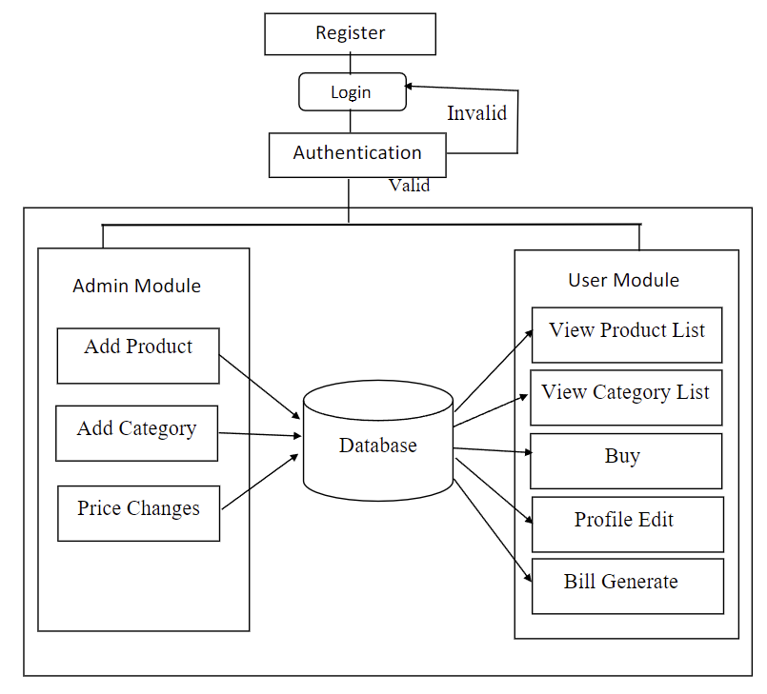

* 1. **Modules Used**

**Customer Module:**

The customer module is a crucial component of any website that allows users to interact with the site, browse products or services, make purchases, and manage their accounts. Here are some key features typically found in the customer module:

**1. User Registration and Login:**

Customers can create accounts by providing basic information such as name, email address, and password. Once registered, they can log in securely to access personalized features and account settings.

**2. Profile Management:**

Users can update their profile information, including contact details, shipping addresses, and payment methods. This ensures a seamless checkout process and improves overall user experience.

1. **Product Browsing and Search:**

Customers can browse through products or services offered by the website, filter search results, and view detailed product descriptions, images, and pricing information.

**4. Shopping Cart:**

The shopping cart allows users to add items they wish to purchase, review the contents of their cart, adjust quantities, and proceed to checkout when ready.

**5. Order Management:**

Customers can view their order history, track the status of current orders, and manage returns or exchanges if applicable. Order confirmation emails are sent to users upon successful purchase.

**6. Wishlist:**

Users can create and manage Wishlist’s, allowing them to save items for future purchase or share them with friends and family.

**Admin Module:**

The admin module is a backend interface that enables website administrators to manage and control various aspects of the site, including content, users, orders, and settings. Here are some key features typically found in the admin module:

**1. Dashboard:**

The admin dashboard provides an overview of key metrics and insights, such as sales performance, website traffic, and customer engagement.

**2. User Management:**

Administrators can manage user accounts, including creating new accounts, updating user information, and moderating user activity.

**3. Product Management:**

Admins can add new products, update existing product listings, adjust pricing and inventory levels, and categorize products for easy navigation

**4. Order Processing:**

The admin module allows administrators to view and manage orders, including processing payments, updating order statuses, and generating invoices or shipping labels.

**5. Content Management:**

Administrators can create, edit, and publish content pages such as blog posts, articles, and promotional banners to keep the website up-to-date and engaging.

**6. Settings and Configuration:**

Admins have access to various settings and configurations to customize the website's appearance, payment options, shipping methods, and other functionalities according to business needs.

Both the customer module and admin module play vital roles in ensuring a smooth and efficient operation of the website, providing users with a seamless shopping experience and administrators with the tools they need to manage and grow their online business.

* 1. **System Architecture**

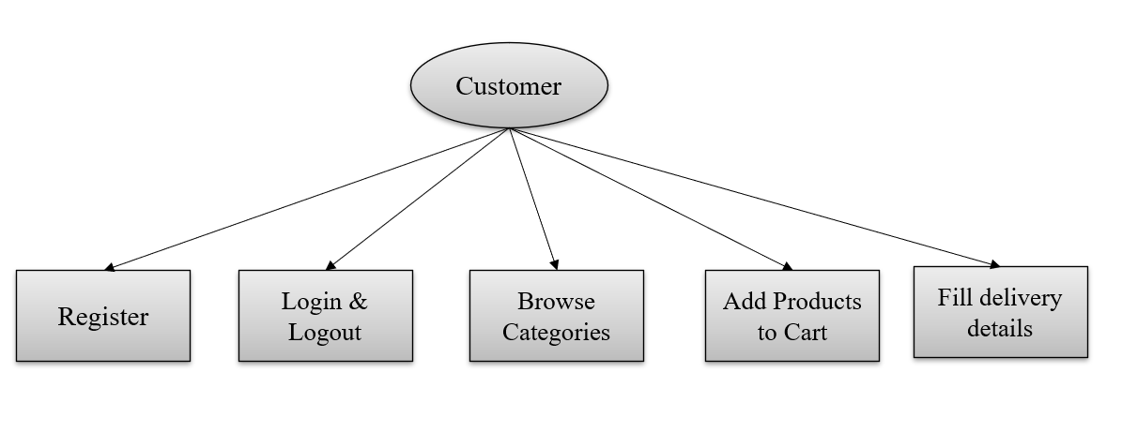**Customer Module:**

**Farmer Module:**

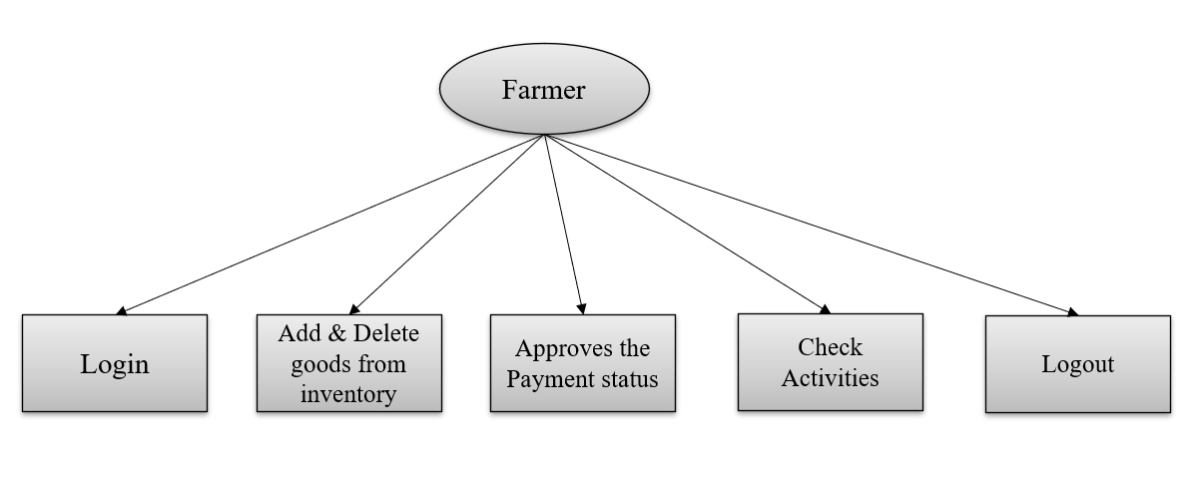

* 1. **Advantages**

**1. Convenience:** Eco Thrive Market allows customers to shop for eco-friendly products from the comfort of their own homes, eliminating the need to visit a physical store.

**2. Wide Selection:** Eco Thrive Market can offer a wider selection of eco-friendly products compared to traditional grocery stores, as they are not limited by physical shelf space.

**3. Accessibility:** Eco Thrive Market's website can be accessed 24/7 from any internet-enabled device, allowing customers to shop whenever it's convenient for them.

**4. Information Availability:** Eco Thrive Market's website can provide detailed information about each product, including its environmental certifications, ingredient list, and eco-friendly packaging.

**5. Community Engagement:** Eco Thrive Market's website can serve as a hub for community engagement, allowing customers to share tips, recipes, and sustainability initiatives. This fosters a sense of belonging and encourages collective action towards environmental conservation.

Overall, Eco Thrive Market's website offers numerous advantages for customers seeking to make environmentally conscious shopping choices, providing convenience, accessibility, information availability, community engagement, cost savings, and a positive environmental impact.

* 1. **Requirement Specification**

**Hardware Requirements:**

1. **Processor Requirement**:

* Intel Core i5/i7 or AMD equivalent.

1. **RAM Requirement:**

* Minimum: 4 GB
* Recommended: 8 GB (especially for heavier workloads)

1. **Storage Requirement:**

* At least 20 GB of free space for the operating system (Windows/macOS)
* Additional space for XAMPP installation (500 MB), website files, databases, development tools, code files, and temporary files.

**Software Requirements:**

**1) Operating System:** Windows or macOS for development environments.  
**2) Web Server:** XAMPP. **3) Database:** MySQL. **4) Back-End Technology:** Server-Side Scripting – PHP.  
**5) Front-End Technology:** HTML, CSS, JavaScript.

**CHAPTER 4**

**IMPLEMENTATION and RESULT**

**4.1 System Implementation:**

The implementation of the Eco Thrive Market website involves a systematic approach to developing and deploying the platform to ensure its functionality, reliability, and user-friendliness. The process encompasses several key stages, each of which plays a crucial role in bringing the project to fruition.

**1) Requirement Analysis**:

The first step in system implementation is to conduct a thorough analysis of the project requirements. This involves collaborating with stakeholders to identify their needs, goals, and expectations for the website. By gathering and documenting detailed requirements, the development team gains a clear understanding of the project scope and objectives.

**Functional Requirements:**

- Shopping for eco-friendly products

- Viewing product details and pricing

- Adding products to the cart

- Placing orders

- Viewing order history

**Non-Functional Requirements:**

- Security

- Performance

- Usability

- Accessibility

**2) Design Phase:**

The design phase of the Eco Thrive Market website is a critical stage in the development process, where the system architecture and user interface are planned and conceptualized to meet the project requirements effectively. This phase involves creating wireframes, mockups, and prototypes to visualize the website's layout, functionality, and user experience. Several key aspects are addressed during the design phase to ensure that the final product meets the needs and expectations of users.

**User Interface Design:**

- The user interface design focuses on creating an intuitive and visually appealing interface that enhances user engagement and usability.

- Designers work on creating layouts, navigation structures, and visual elements that are consistent with the website's branding and user experience guidelines.

**Functional Design:**

- Functional design focuses on defining the functionality and features of the website based on the project requirements and user needs.

- Designers create use cases, user stories, and interaction diagrams to describe how users will interact with the website and accomplish tasks.

**3) Development Phase:**

The development phase of the Eco Thrive Market website is a pivotal stage in the software development lifecycle, where the conceptualized design and planned architecture are transformed into a functional and fully operational website. This phase involves coding, testing, and integration of various components to build the core features and functionalities of the website.

**Coding and Implementation:**

- Developers begin by translating the design specifications and requirements into code using programming languages and frameworks selected for the project. They follow coding standards, best practices, and design patterns to ensure the codebase is maintainable, scalable, and efficient.

- The development process encompasses building the backend infrastructure, such as databases, servers, as well as the frontend components, including user interfaces, forms, and interactive elements.

**4.2 Testing and Validation:**

Testing and validation are crucial stages in the development life cycle of the Eco Thrive Market website, ensuring that the website meets the specified requirements, functions as intended, and delivers a seamless user experience. The testing process encompasses various techniques and methodologies to identify and address any issues, bugs, or discrepancies in the website's functionality, usability, and performance.

**1. Functional Testing:**

- Functional testing involves verifying that each feature and functionality of the Eco Thrive Market website performs as expected and meets the defined requirements. Test cases are developed based on the functional specifications and user stories outlined in the project documentation.

- Test scenarios are created to cover various user interactions and use cases, such as browsing products, adding items to the cart, and placing orders. Testers execute these scenarios systematically to validate the behavior of the website under different conditions.

**2. User Acceptance Testing (UAT):**

- User acceptance testing involves evaluating the website from the perspective of end-users to ensure that it meets their needs, expectations, and usability requirements. Testers simulate real-world usage scenarios and assess the website's ease of use, intuitiveness, and overall user experience.

- Feedback from stakeholders and end-users is collected during UAT to identify any usability issues, interface inconsistencies, or areas for improvement. Testers collaborate with designers and developers to address these issues and enhance the user experience of the website.

**3. Performance Testing:**

- Performance testing evaluates the responsiveness, scalability, and stability of the Eco Thrive Market website under different load conditions and usage scenarios. Testers measure key performance metrics, such as response times, throughput, and resource utilization, to assess the website's performance characteristics.

- Load testing, stress testing, and scalability testing are performed to determine the website's ability to handle concurrent user sessions, peak loads, and scalability requirements. Performance bottlenecks and optimization

**4.3 Results**

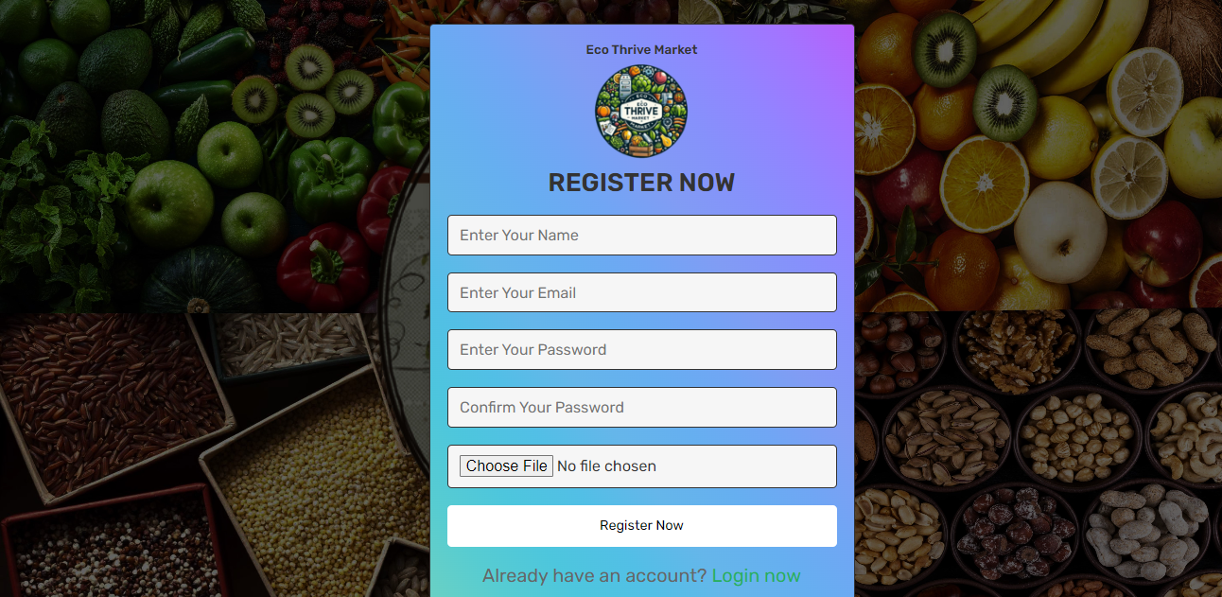

**Figure 1:** Register Page

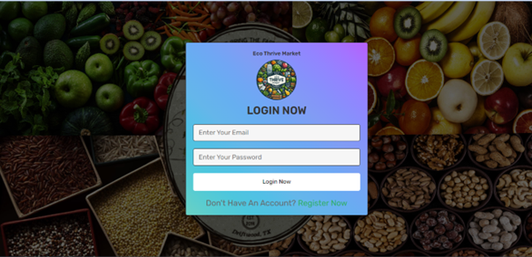

**Figure 2:** Login Page

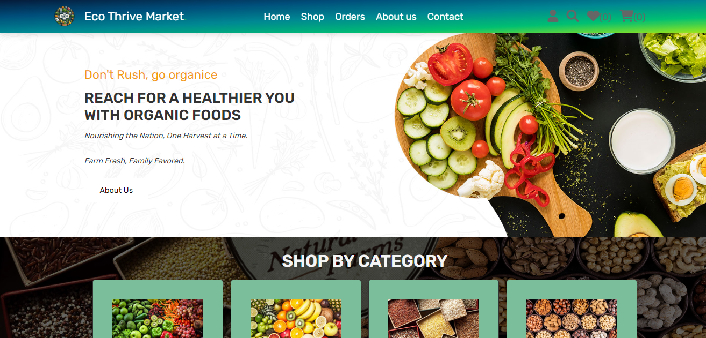

**Figure 3:** Home Page

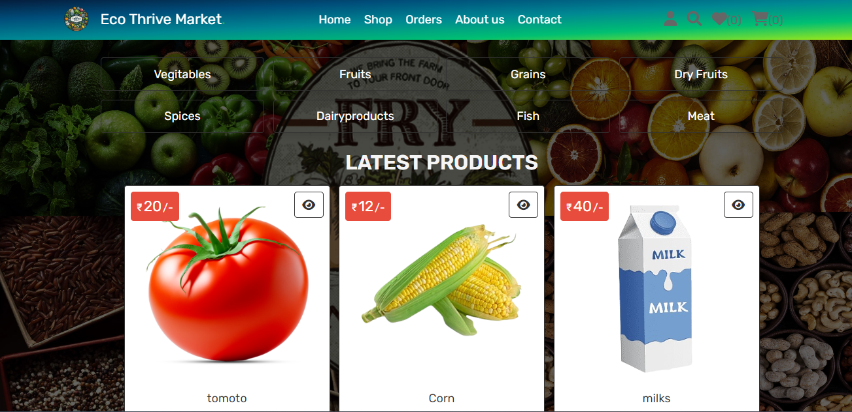

**Figure 4:** Shop Page

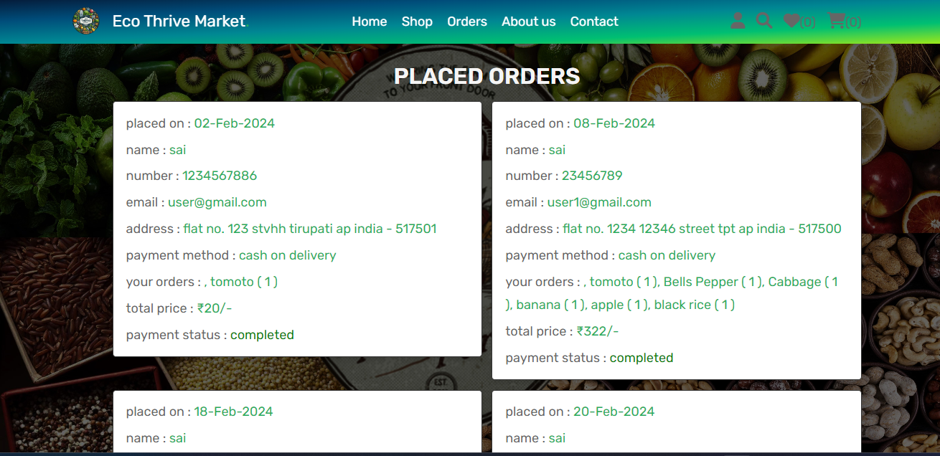

**Figure 5:** Orders Page

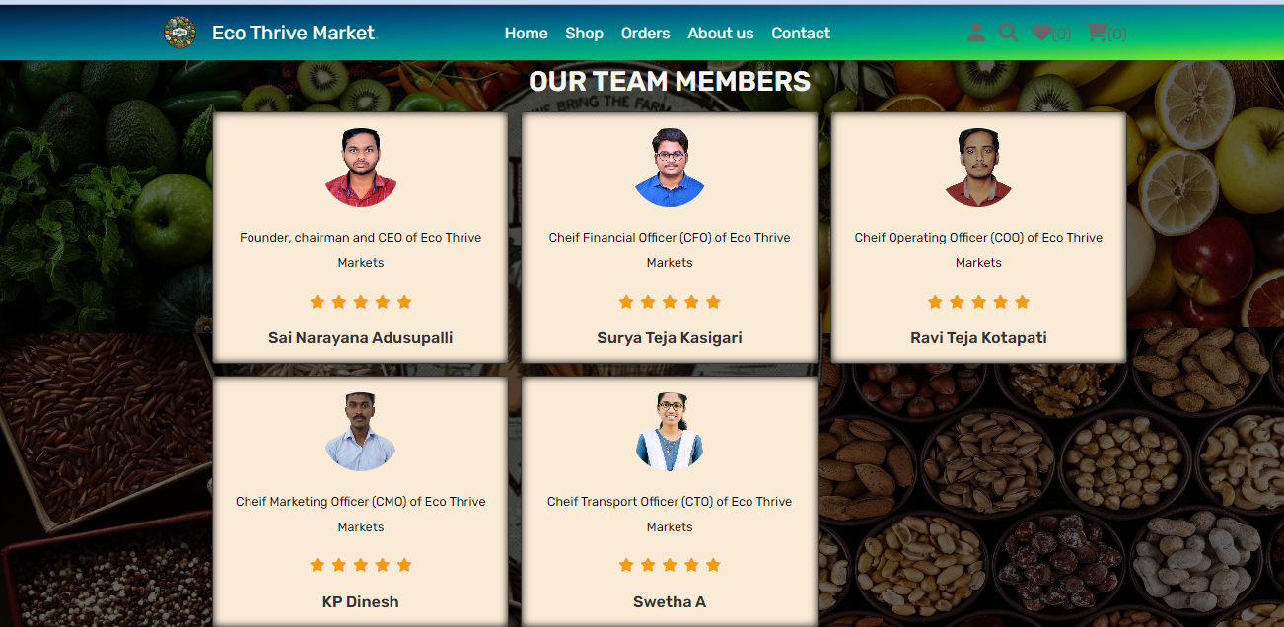

**Figure 6:** About us Page

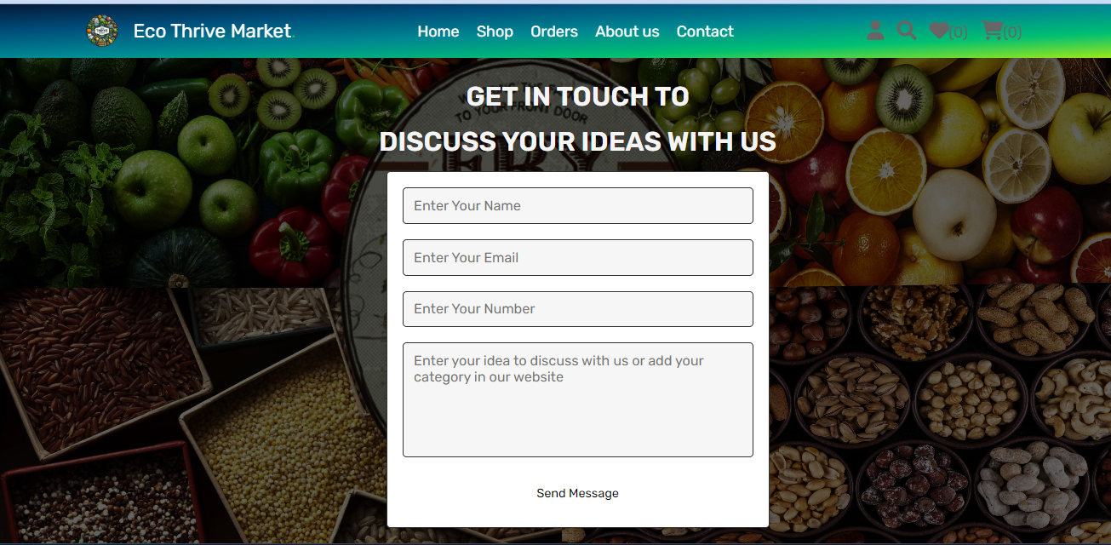

**Figure 8:** Admin Dashboard Page

**Figure 7:** Contact Page

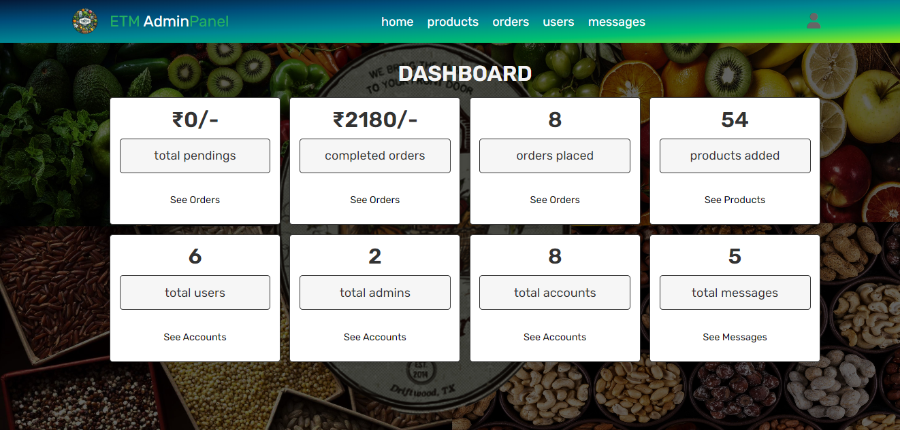

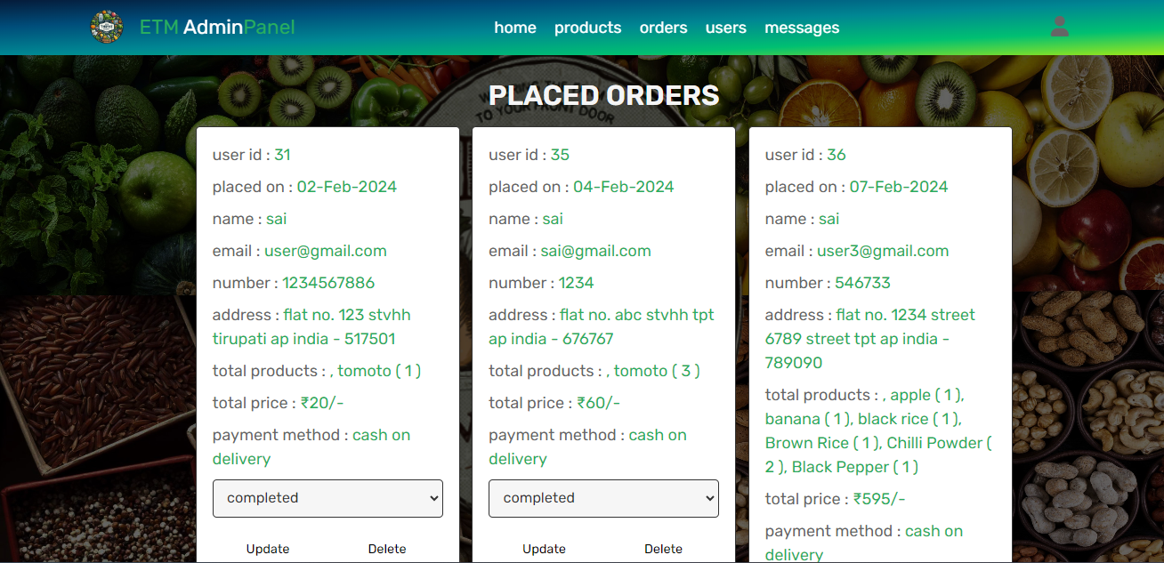

**Figure 9:** Admin Orders Page

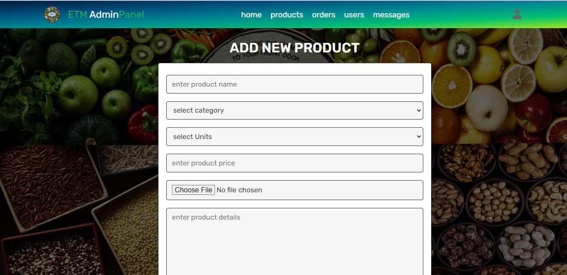

**Figure 10:** Admin Products Page

**CHAPTER 5**

**CONCLUSION**

In conclusion, Eco Thrive Market stands as a beacon of sustainability and conscious consumption in the realm of grocery shopping. With its unwavering commitment to environmental responsibility, community engagement, and ethical sourcing, it has redefined the concept of a grocery store. Through innovative practices such as zero-waste initiatives, locally sourced produce, and eco-friendly packaging, Eco Thrive Market not only caters to the needs of its customers but also serves as a catalyst for positive change in the broader food industry. By patronizing Eco Thrive Market, consumers not only nourish their bodies but also contribute to the health of the planet and support a more equitable food system. As we look towards the future, it is evident that Eco Thrive Market's vision of sustainability will continue to inspire and guide us towards a more prosperous and harmonious relationship with our environment and each other.

**FUTURE SCOPE:**

The future scope of your project, Eco Thrive Market, is vast and promising. Here are some potential directions:

* **Expansion of Product Categories:** As the demand for sustainable products grows, you can expand the range of product categories offered on the platform. This could include everything from clothing and accessories to home goods, beauty products, and even food items.
* **Global Reach:** While starting locally or nationally, there’s a huge potential for expanding the services globally. This would connect eco-friendly suppliers and consumers worldwide, making sustainable products more accessible.
* **Technology Integration:** Leveraging technology like AI and machine learning could enhance user experience through personalized recommendations, better search functionality, and efficient customer service.
* **Convenience:** Eco Thrive Market allows customers to shop for eco-friendly products from the comfort of their own homes, eliminating the need to visit a physical store.
* **Community Engagement:** Eco Thrive Market's website can serve as a hub for community engagement, allowing customers to share tips, recipes, and sustainability initiatives. This fosters a sense of belonging and encourages collective action towards environmental conservation.

**GITHUB LINK**

**https://github.com/SURYA2745/ECO-THRIVE-MARKET**

**VIDEO LINK**

**https://drive.google.com/file/d/18vywcOa0PdBkFwzUQqCL5OUvgYegbP0z/view?usp=sharing**

**REFERENCES**

[1]. Kuhar. A. & Juvancic. L. (2008), “Determinants Of Purchasing Power For Organic And Integrated Fruits And Vegetables In Slovena”, Agricultural Economics Review, Vol.11(2), 70-83.

[2]. A. Lakshmanan & Dr. V.Karthik. (2016). Consumer's buying behaviour towards online shopping. A case study of Flipkart.com users in Udamalpet Town. International journal of Recent Research & Applied Studies. ISSN- 2349-4891.

[3].<https://www.strategy-business.com/article/The-rise-of-the-eco-friendly-consumer>